**Smart Security System using laser and motion detection**

Joy Krishan Das1, Abhijit Kumar Pal1, Fayza Rezwana Oishi1, Md. Mehedi Hossain1

1Department of Computer Science & Engineering

BRAC University

66 Mohakhali, Dhaka, Bangladesh.

E-mail: joykrishan10@gmail.com, abhijitkp129@gmail.com, rezwanaoishi786@gmail.com, Mehedihossain64@gmail.com

***Abstract-* since our world is turning more chaotic as each day progresses, weak security systems are being breached with ease. Moreover, if we try to make it stronger and more effective, sadly we have to deal with the insane amount of the cost of the quality components. Therefore, in this**

**paper, we try to introduce a cost efficient way to ensure smart and strong security. Using servo motors, Arduino mega, PIR sensor, LDR, GSM module etc. to construct the proposed system which can be bought and used by a person with a medium income to secure his valuable things and also can be installed in shops. A prototype of the model has been made to show the efficiency, productivity and cost analysis of the proposed system. The result displays** that **the system** is **cost-effective and affordable to the middle class people and small shopkeepers of the community.**

**Keywords: security system for home, cost efficient security system, false door, easy installation, Arduino mega, Servo motor**

1. INTRODUCTION

There are lots of robbery happens in houses and also in small shops. Though the amount stolen from houses and shops are not in Millions or billions but it could be the last asset a middle class person or a small shopkeeper might have. Sometimes, the robbery is so small in amount that even Police does not file any complaint. A person who lost his last asset can only feel the pain. Sometimes, the robbery is resulted of personal rivalry among the family or in the market.

There are lots of security systems out there in the market already. They give very high security but they come with a very high price. Thus, middle class people or a small shopkeeper cannot even imagine to buy one. Moreover, there are also some cheap security systems are available which comes in a small shape but it has a problem. Even though this system provides very good security but it can be easily broken and if someone can enter into the system by breaking it, he can have every valuable thing in it and high security system cannot stop the burglar.

In our system we have solved two problems. Firstly, we have created a system in a way that is cost efficient and provides good security. Our target market is middle class people and also small shopkeepers. Using Arduino mega, PIR sensor, LDR, GSM module combined, we have been able to create a security system which will be in middle class people’s range to buy. Moreover, it is also very easy to install and operate so that people do not have to know much about technology to use it. Secondly, in most cases, if someone breaks the vault or the system there is nothing that can prevent him from stealing. However, we have created a false door using servo motor to create an illusion that the vault is empty. It does not only create the illusion but also hides the valuable things. Whenever someone tries to break it with anything, the door automatically rises and hides the valuable assets. This way, assets could be saved and also the owner can be informed right away.

   The rest of the paper is organized as follows: Section II details the background study behind the realization of this work. Section III illustrates the overall idea of the proposed model alongside the circuit details of the proposed model and hardware implementation. Section IV describes the experimental analysis based on the proposed model, and finally section V concludes the paper and discusses future work.

1. LITERATURE REVIEW

In the era of modern technology, people have invested time on building an efficient smart lock system using the instrument available in the current time. The concern here is to make a system which is both cost efficient and provide a better security to avoid security breach and protect valuables things from the penetrator.

To meet the need of smart security system, some work has been done by others to build such a system. In this system, a digital interface is used instead of more conventional physical key to access the system [1],. Here the components use is Raspberry Pi, Electronic Lock, Bluetooth lock, digital password. The system detect person with PIR Sensor and prompt a message to put password which can be done with the software too but phone has to connect with the security system and log the info. Wrong Password input send email stating “Intruder” to the admin of the system and during power cut the system needs to open manually and provide no other security measurement. In another approach to build such a system to prevent an attacker from accessing the safe is to detect the person using short range IR sensor and take a snapshot of that person to send it to the server for facial recognition system to analyze the image and distinguish between the approved and intruder[2],.

Some more work has been done on the system development where the proposed system is to use bimodal biometrics which consist of fingerprint and iris Scanner which then run a check with the saved data from database and these require a complex calculation to recognize the authenticate person[3].In another work, the approach is  based on security system  combining with RFID tag, Mems Technology, GSM System and microcontroller and sending password on different levels  to verify. This Process is time consuming [4].

There are several innovative data structures such as ZigBee that are used to store information obtained from different sensors [5]. However, in many other methods Arduino mega and programmable interface microcontroller is used for storing purpose [6]. In such models, GSM module and biometric identification was used instead of motion and laser sensors. Another implementation works with Arduino uno along with PIR motion sensor and Wi-Fi module to set up a wireless security system[7].

So , all these security system provides security in multiple level and as per the consumers requirement but with high tech configuration comes high cost which will not be affordable for people from middle class who want to secure their personal vault form penetrator. Our proposed System compared with above models meets the requirements which provide security and also cost way less. The system stands alone because it does not only provide a digital smart security system but also raise a false door if penetrator trying to break the vault by using machinery likes drill and hammer.

1. PROPOSED MODEL
2. Components :

A prototype has been built in order to provide a primary idea of how the device should look like and behave. The main this to consider is security. So, we design it in a way that back door is not visible and interaction is good with user. Arduino-mega has been used as the processing unit for the device alongside other cheap sensors and materials for the model to be cost effective. Fig. 1 shows the block diagram of the proposed model.

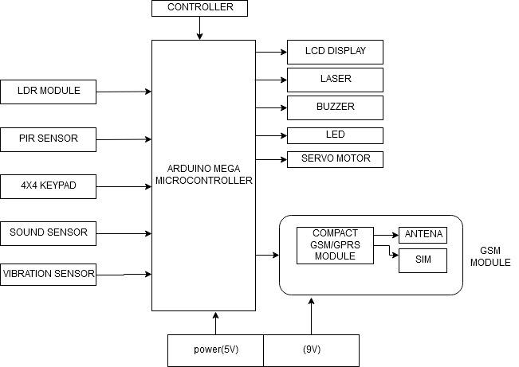

Block Diagram of the system

As shown in the above diagram, the whole system has only two fundamental steps for it to operate successfully. The first is successful login process. The data is read by LDR which is very cheap to letting authorities knows someone trying accessing the vault by turning on the buzzer. The keypad takes matrix input of data to verify the password. The sensor uses the I2C-bus to interface with the Arduino to display in LCD. PIR sensor has the flash memory capacity of 256 KB and was deemed as an effective processing unit for the proposed model. The Arduino Mega is a microcontroller board based on the ATmega1280 (datasheet). It has 54 digital input/output pins (of which 14 can be used as PWM outputs), 16 analog inputs, 4 UARTs (hardware serial ports), a 16 MHz crystal oscillator, a USB connection, a power jack, an ICSP header, and a reset button. Arduino processes this directional value and gives output to corresponding GSM to warn the owners about potential threads.

As for the other components, Sound and vibration sensors input the analog data and input in mega. Thus, for servo to operate need a setting of proper threshold level. It takes a high potential which mega provides very easily.

1. Circuit details of the proposed model:

Below we can see the circuit diagram.

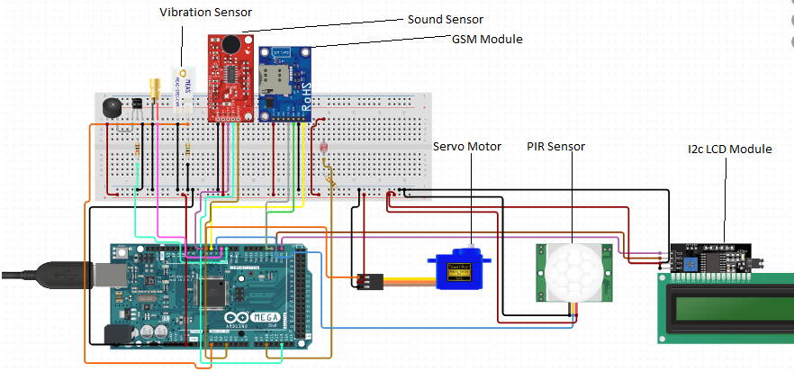

Fig: Circuit Diagram

In this diagram, we see Arduino is giving 5V and GND to all. Vibration sensor is connected to pin 4 , sound sensor with A0 and servo motor with pin 10. Whereas, PIR at 12 , LDR at 26 , LED at 13 and Buzzer at 11. LCD I2C with pin 3 and GSM with 52 and 52. Here row of keypad connected to 9, 8, 7, 6 pins and column of keypad connected to 5, 4, 3, 2 pins. There is a transistor for buzzer. Transistor, LDR and Vibration sensor are connected to a register each.

1. Hardware implementation:

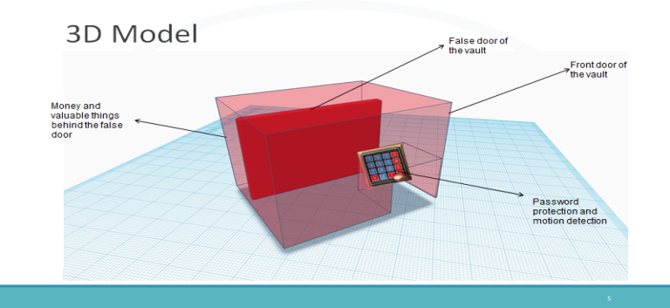

1. Front Part:

In front part there is an Arduino mega 2560 is connected to 4x4 keypad , PIR sensor , LED, LDR , Buzzer , GSM and L2C with LCD . It was kept in the front of the box so that it can view from outside . In this , there a laser is placed in the box that puts the light in LDR module . It is used for detecting and activating the buzzer . A 4x4 keypad is placed below the laser to take password . There is PIR just behind keypad to detect motion and turn on the LED so that it will light up the keypad. After verification there is an LCD was placed up of the square hole to display password in “#” and whether vault is open or password is wrong . GSM module is under the vault to sent a message if the password is wrong consecutively three times.

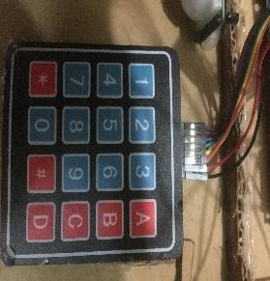

Fig: 4*4 Keypad membrane

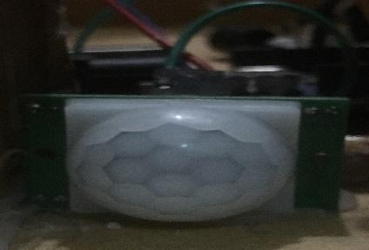

Fig: PIR Motion Sensor



Fig: Sound Sensor Module

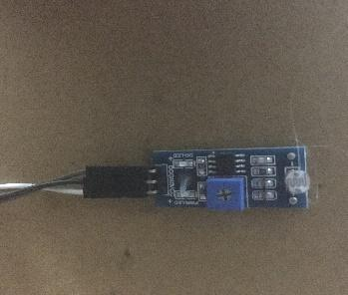

**Fig:LDR**

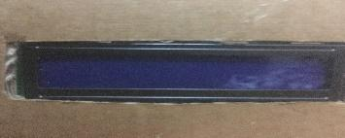

**Fig:** 16*2 LCD Display

2..Rare Part:

In rear part there is a servo , sound sensor and vibration sensor connected with Arduino mega. Vibration sensor is connected to the whole vault and sound sensor is placed outer part of the vault . The servo of connected with a small pipe and cork sheet to represent the false door . As it is light enough to carry the weight by servo. It is given enough space to turn 90 degrees and back to initial position when there is activation of vibration and sound sensor together after crossing the threshold level.

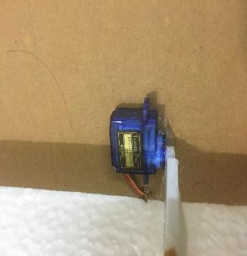

Fig:Servo motor

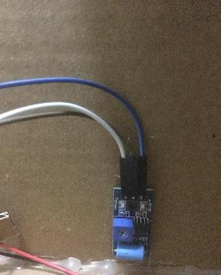

Fig:Vibration sensor

1. Working Process of the Model

Model -1

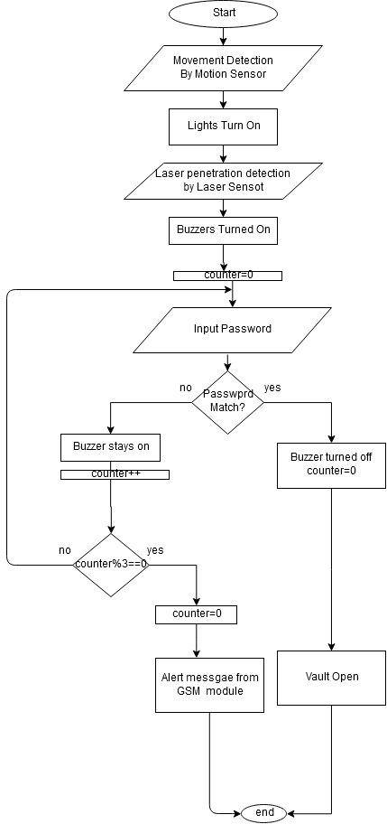

1. Login Verification:

a. Algorithm:

1. password length is selected
2. Master password is given
3. mapped the keypad in row and column
4. Initialized class of an instance of password
5. LCD initialized
6. When the hand pierced through the laser light it will interrupt the threshold of LDR
7. When the buzzer will be high and start making sounds .
8. We give password
9. If master key and custom key matched the password is right
10. When the buzzer is on and password is right the buzzer turn off else it will be stay buzzing
11. If PIR sensor detect something it will automatically turn on led
12. If the password is wrong three times it will send a warning message to the owner

Model -2

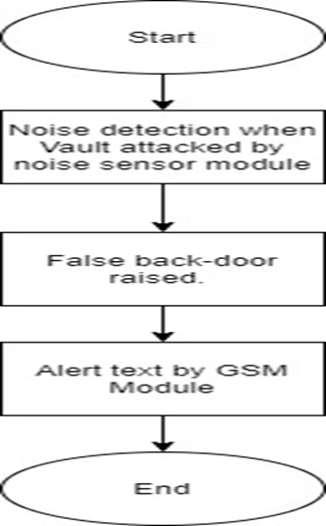

2. Lock Down Process:

b. Algorithm:

1. 1st we initialized sound sensor , servo motor and vibration sensor
2. We took a variable call “measurement” to measure the pulse value of vibration sensor
3. To take sound sensor input we took a variable call “sensorValue” and for output “outputValue” .
4. outputValue use constrain(255-map()) to map sensorValue to the range of the analog out, decrease a bit and constrain the value
5. when the value of measurement is 1000 or more and value of output Value is 50 or more the servo will turn from 90 degrees to 0 degrees .
6. Meaning our false door will rise when sound threshold is 50 or more and vibration threshold 1000 or more
7. EXPERIMENTAL ANALYSIS
8. System test :
9. Login: While testing we first see if the buzzer is turned on or not when we pierce the laser light. As the LDR threshold interrupted we heard the buzzer. Then we saw as the PIR sensor detects the hand , the led turn on. We check whether the password is right or wrong . when password is right the LCD display open . when wrong it display try again. After failing the third attempt put correct password the GSM sends a warning message to the owner.

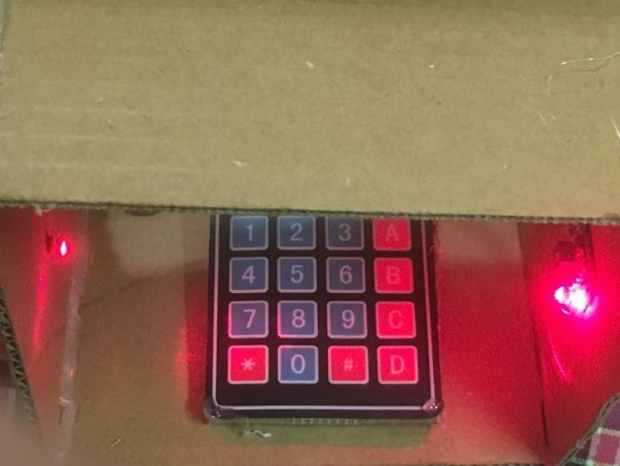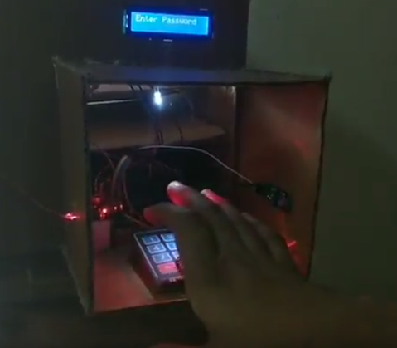

Fig : login verification

1. False door :Then we use drill sound but false door doesn’t work , we try vibrating the vault but it doesn’t work . Finally , when both at a time happen servo turn 90 degree along with the cork sheet false door we build.

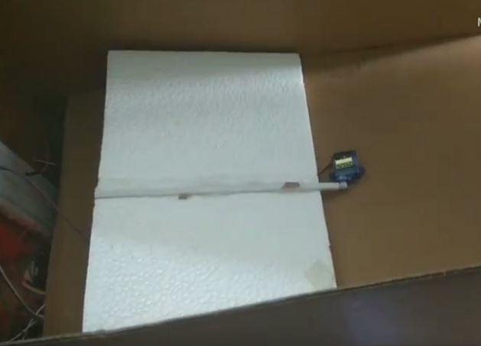

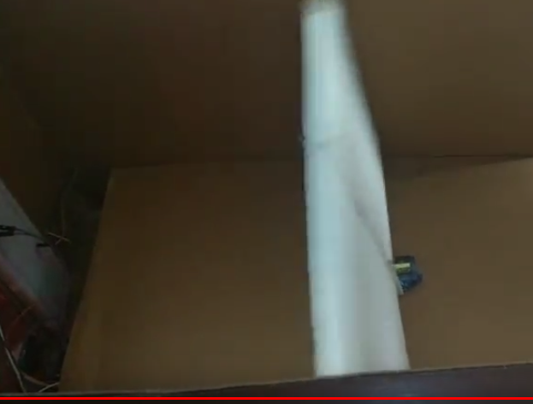

Fig : false door

1. Cost analysis:

One of the vital issues behind the proposal of smart security system model was to reduce the total cost with proficient security system. As affordability is a significant issue for most of the middle class people and small shop owners. WE tried to make the system at a very low cost. Table I provides the cost analysis of the prototype based on the proposed system.

|  |  |
| --- | --- |
| components | Price in BDT |
| Arduino Mega | 745 |
| PIR Motion Sensor | 84 |
| Laser | 30 |
| LDR | 10 |
| GSM Module | 1800 |
| Servo Motor | 145 |
| 4*4 Keypad membrane | 74 |
| 16*2 LCD Display | 135 |
| Sound Sensor Module for Arduino | 120 |
| Vibration Sensor | 110 |
| total | 3253 |

1. CONCLUSION

The high cost of Security system and the lack of affordability have been a major concern. In the presented work, the cost-effective smart security system is an attempt to provide middle class people and small shop owners security that they deserve.

1. Limitations of the system:

One major limitation in our system is, if anyone knows about the password, he/she can unlock the system. Therefore, the password has to be kept very private.

1. Future Work:

In near future, we are planning to introduce two factor password verification, where only an authentic person can enter into the system. Firstly, he/she will enter the password, and then he/she will receive another code pass through their phone and then entering that particular code will unlock system finally.

Lastly, we are aiming to work in large scale; we are going to use this same idea to build a larger vault which can be installed in some warehouses where things can be stored and safe.

ACKNOWLEDGMENT

The authors would like to thank Dr. Md. Ashraful Alam, Raihana Shams Islam Antara, Md. Nazmus Sakif for giving us a platform where we could identify a problem and tried to implement an idea to solve it.

REFERENCES

[1] A.Churi, A.Bhat, R.Mohite,P.P.Churi, “*E –zip: An electronic lock for secured system”,* *2016 IEEE International Conference on Advances in Electronics, Communication and Computer Technology (ICAECCT),Rajarshi Shahu College of Engineering, Pune India. Dec 2-3, 2016*

[2] V.J. Saglani, A.V. Gupta, R.Sarma, S.Pathak, Dr. D Rekha, “*IoT based Smart Safe System”,* International Conference on Computational Techniques, Electronics and Mechanical Systems (CTEMS*),*Vellore Institute of Technology, Chennai, Tamilnadu, India *.*

 [3] k. Okokpujie, O. Modupe, E. Noma-Osaghae, O. Abayomi-Alli, E. Oluwawemimo , “*A Bimodal Biometric Bank Vault Access Control System”.* International Journal of Mechanical Engineering and Technology (IJMET), 9(9), pp. 596-607.

[4] A.S.Kale , A.V.Deshmuk, M,V Benodkar, P.k. Nage, S, F. Fukate  ,*”Design of Banking Security System Using Mems And Rfid Technology”,*The International Journal Of Engineering And Science ISSN (e): 2319 – 1813 ISSN (p): 2319 – 1805

[5] Zhangxing, Fuyaoxian, & Wangyingguan. (2012). Design and implementation of smart home monitoring system based on msp430. 2012 IEEE Symposium on Electrical & Electronics

[6] Engineering (EEESYM). [3] Nayyar, C., Valarmathi, B., & Santhi, K. (2017). Home security and energy efficient home automation system using arduino. 2017 International Conference on Communication and Signal Processing (ICCSP). [4] Andriansyah, M., Subali, M.,

[7] Andriansyah, M., Subali, M., Purwanto, I., Irianto, S. A., & Pramono, R. A. (2017). e-KTP as the basis of home security system using arduino UNO. 2017 4th International Conference on Computer Applications and Information Processing Technology (CAIPT).